1. The Model interface
The Model is a Java interface used to pass data from your controller to your front-end view (like Thymeleaf, JSP, or FreeMarker). It acts essentially like a backend-to-frontend map or dictionary.
- How it works: You pass it as a parameter into your controller method. Spring automatically injects it for you.
- Return type: Your method returns a simple String, which represents the name of the HTML/view template.

2. The ModelAndView class
ModelAndView is a holder class that encapsulates both the model attributes and the view name into a single return object.
- How it works: Instead of accepting a Model as a parameter, you instantiate a new ModelAndView object inside your method, pack it with your data, tell it where to go, and return the whole package.
- Return type: The method must return a ModelAndView object.
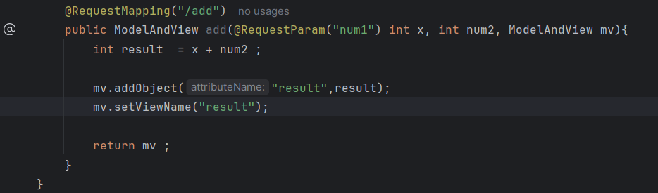

215_For Alien:
Instead of two numbers, we can do the same by adding a new Alien with a new Id and a name.
Step 1: Create An Alien class.
Step 2: In the homecontroller, create a new controller